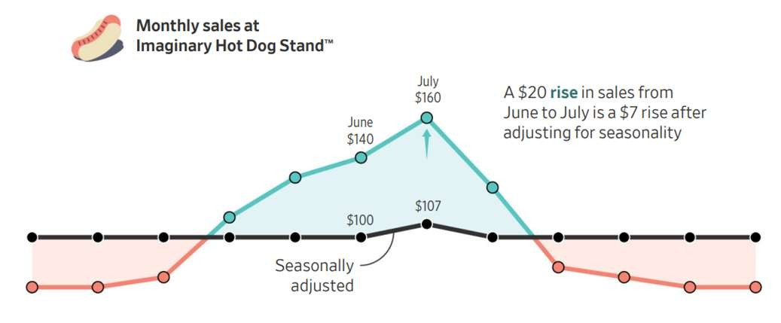

Business Analytics

Chapter 8 Time Series Analysis and Forecasting



Introduction

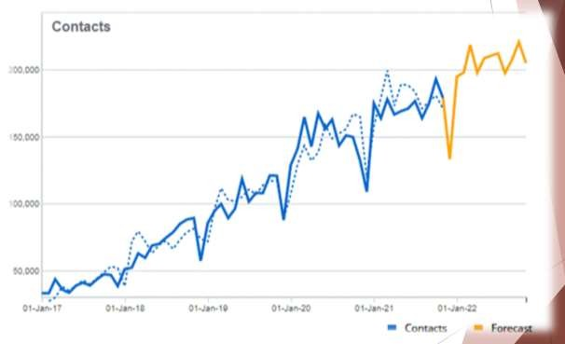

Introduction

* Suppose you are asked to forecast the sales for hot dogs for the next year:
* Could use:
* 1. Quantitative Methods – Expert judgment
* 2. Quantitative Methods – Using data, models, analytics
  + Past information about the variable being forecast is available.
  + The information can be quantified.
  + It is reasonable to assume that past is prologue.



Introduction

* **Objective:**
  + Uncover a pattern in the time series
  + Extrapolate the pattern into the future.
* The forecast is based on past values of the variable and/or on past forecast errors.
  + This is much easier to do and collect in modern times

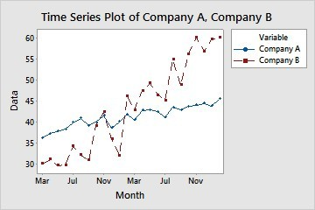

Time Series Patterns

Horizontal Pattern Trend and Seasonal Pattern

Trend Pattern Cyclical Pattern

Seasonal Pattern Identifying Time Series Patterns



Time Series Patterns

* **Time series:**
  + A sequence of observations on a variable measured at successive points in time or over successive periods of time.
* Time:
  + hour, day, week, month, year, or any other regular interval.
  + The pattern of the data is important in understanding the series’ past behavior.
* Is the behavior of the times series data of the past is expected to continue in the future?

**If so, it can be used as a guide in selecting an appropriate forecasting method.**

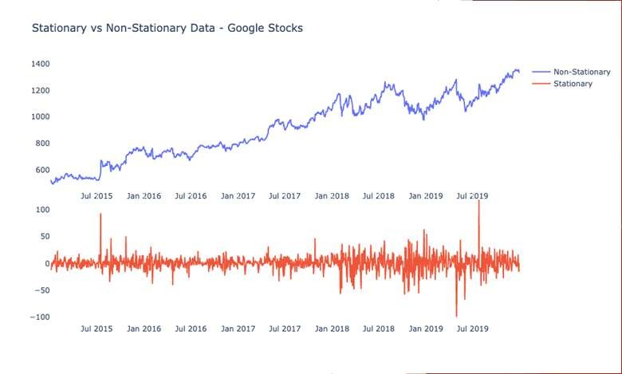

Time Series Patterns

* **Horizontal Pattern:**
  + Exists when the data fluctuate randomly around a constant mean over time.
* Stationary time series: It denotes a time series whose statistical properties are independent of time:
  + The process generating the data has a constant mean.
  + The variability of the time series is constant over time.
  + Stationary series have a horizontal pattern

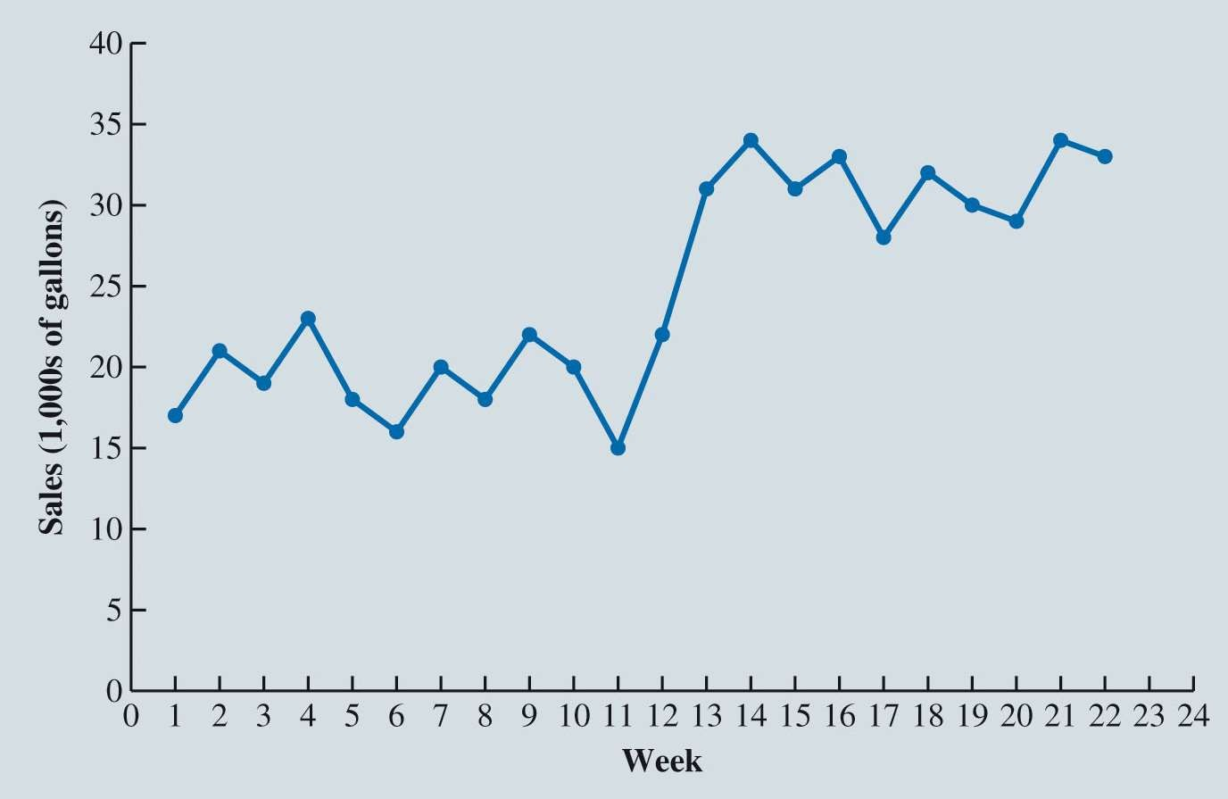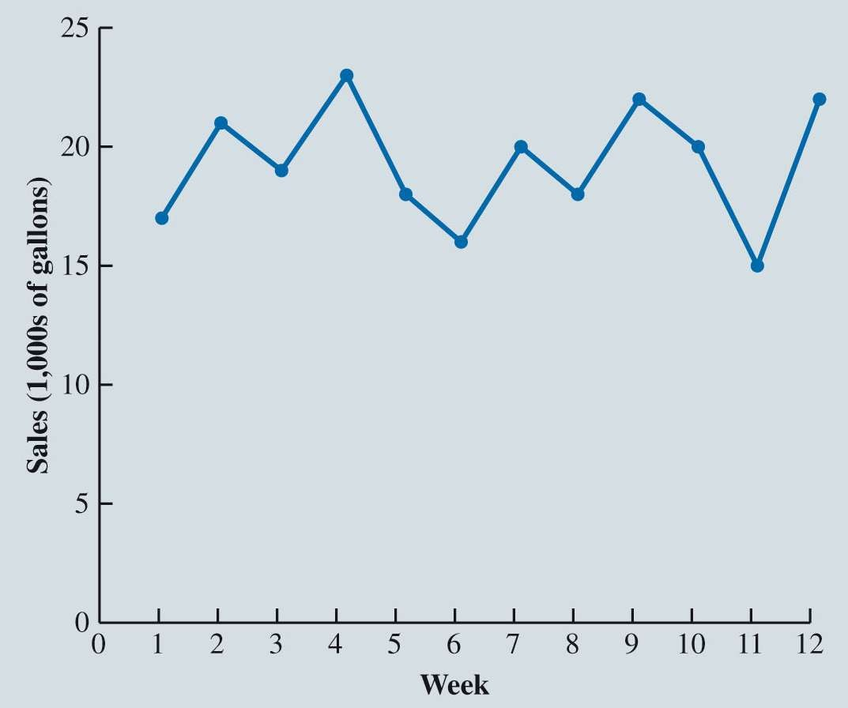

Example – Horizontal Pattern

Gasoline Sales Time Series Plot

Gasoline Sales after Contract State Police

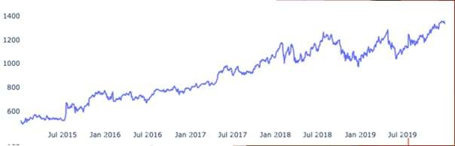

Time Series Patterns

* **Trend Pattern:**
  + A trend pattern shows gradual shifts or movements to relatively higher or lower values over a longer period of time.
* A trend is usually the result of long-term factors such as:
  + Population increases or decreases.
  + Shifting demographic characteristics of the population.
  + Improving technology.
  + Changes in the competitive landscape.
  + Changes in consumer preferences.

Google Stocks

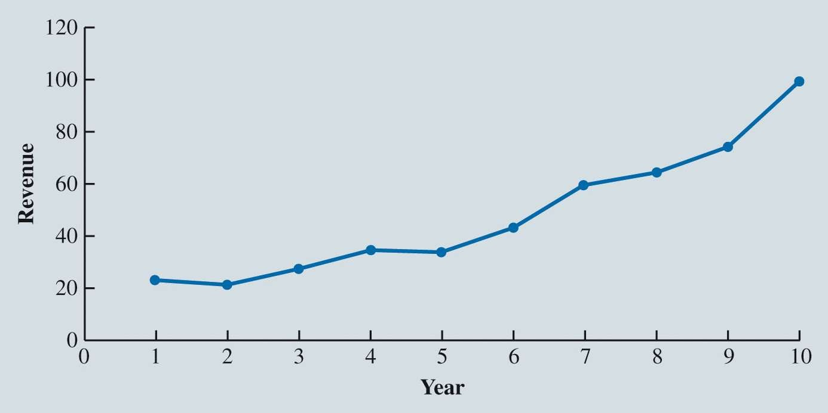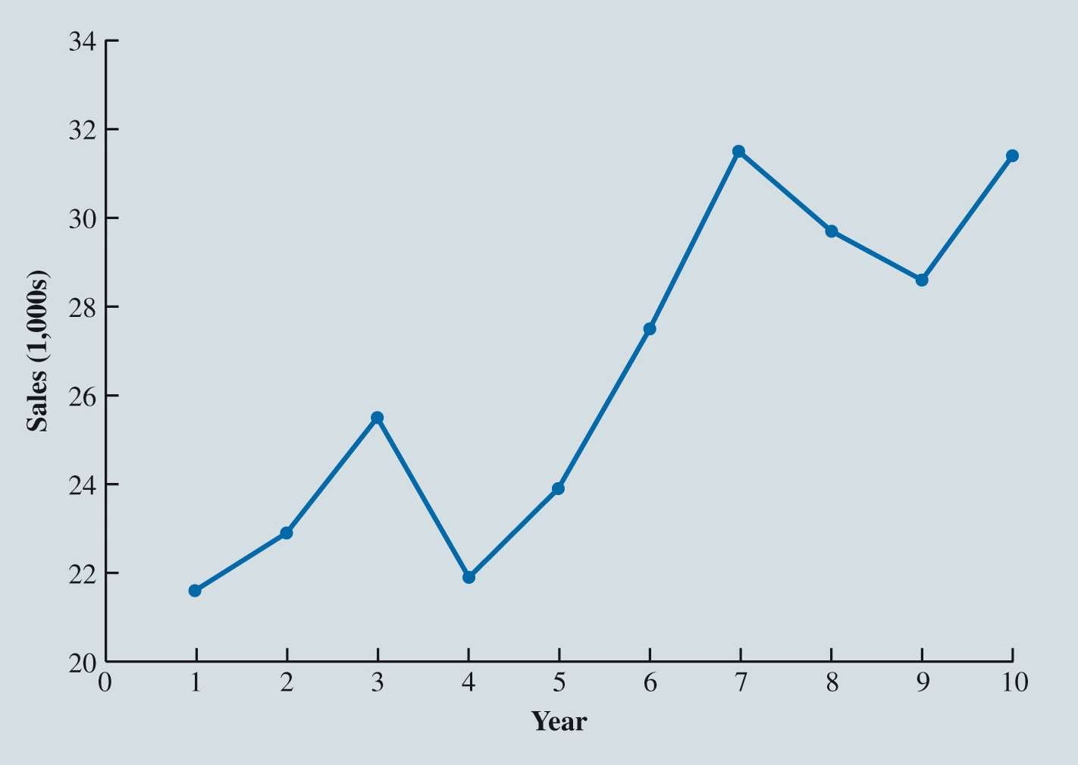

Example – Trend Pattern

Bicycle Sales Time Series Plot

Cholesterol Drug Revenue Times Series Plot ($ millions)

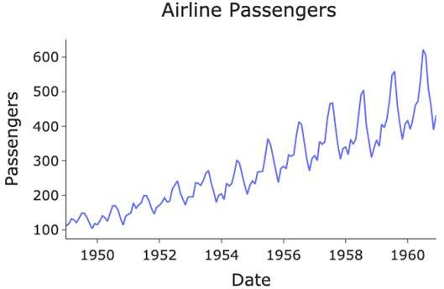

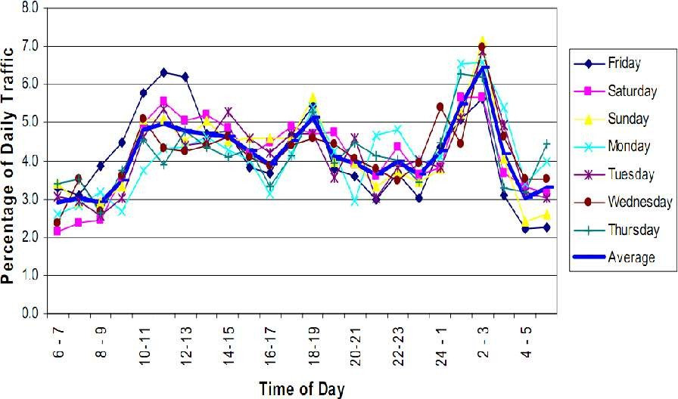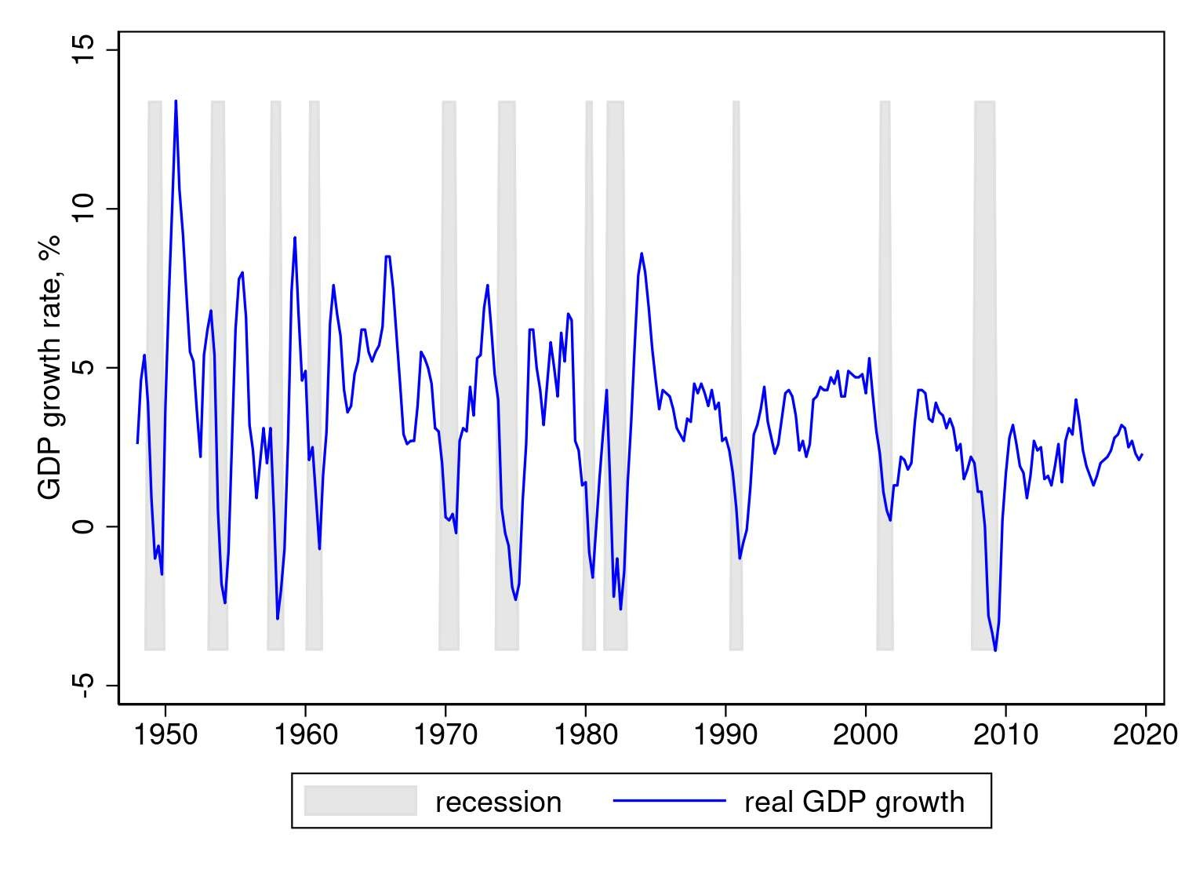

Time Series Patterns

* **Seasonal Pattern:**
  + Seasonal patterns are recurring patterns over successive periods of time.
* The time series plot not only exhibits a seasonal pattern over a one-year period but also for less than one year in duration.



Time Series Patterns

* **Cyclical Pattern:**
  + An alternating sequence of points below and above the trendline that lasts for more than one year.
  + Examples:
    - Periods of moderate inflation followed by periods of rapid inflation
    - Business Cycle: a cycle or series of cycles of economic expansion and contraction.



Time Series Patterns

**Identifying Time Series Patterns:**

* The underlying pattern in the time series is an important factor in selecting a forecasting method.
* A time series plot should be one of the **first analytic tools.**
* We need to use a forecasting method that is capable of handling the pattern exhibited by the time series effectively.



Forecast Accuracy

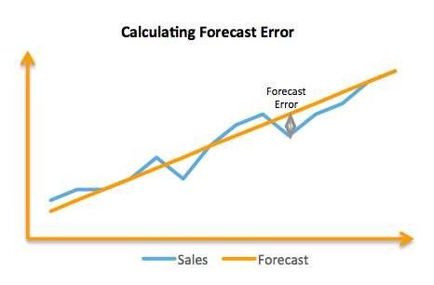

Forecast Accuracy

* **If I asked you what do you think tomorrow’s temperature is going to be?**
  + What would you say?
  + Why would you say that?
* **Naïve forecasting method**: Using the most recent data to predict future data.



Forecast Accuracy

* How to measure forecast accuracy?
* **Forecast error**
  + Measures to determine how well a particular forecasting method is able to reproduce the time series data that are already available.
    - Forecast error.
    - Mean forecast error (MFE).
    - Mean absolute error (MAE).
    - Mean squared error (MSE).
    - Mean absolute percentage error (MAPE).

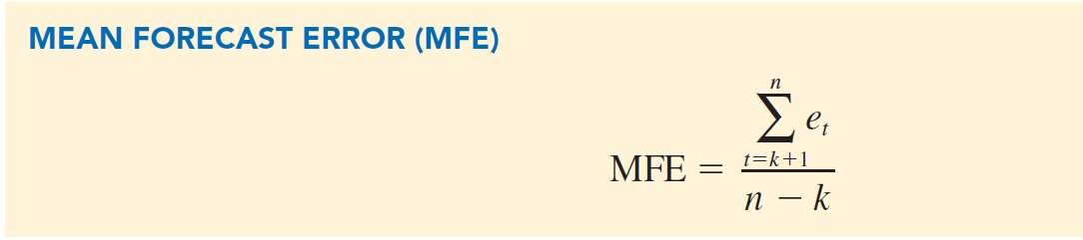

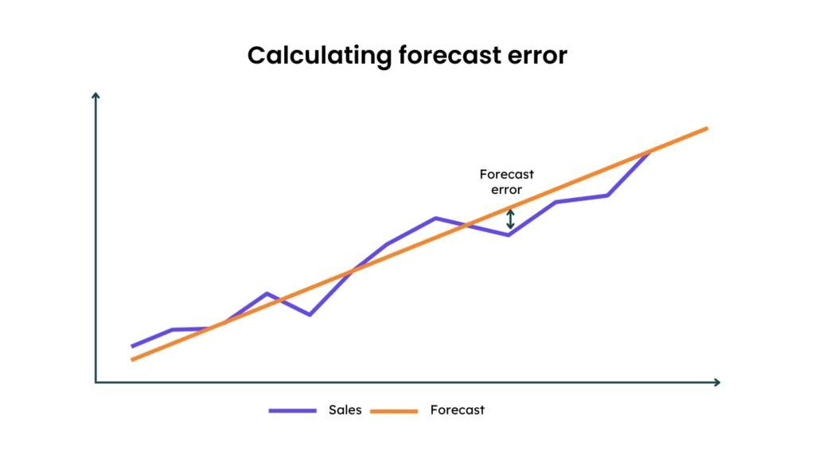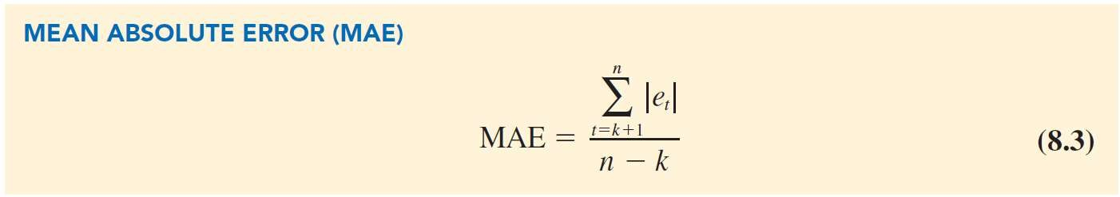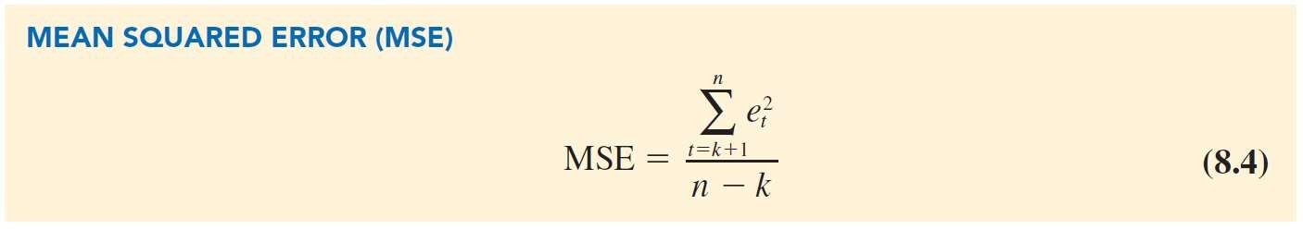

Forecast Accuracy

**Forecast Error**: Difference between the actual and the forecasted values for period *t*.

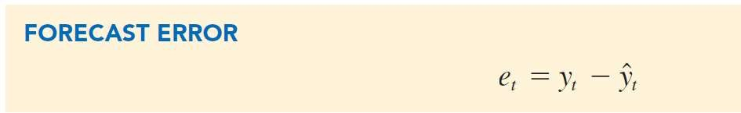

**Mean Forecast Error:** Mean or average of the forecast errors.



Forecast Accuracy

**Mean Absolute Error (MAE):** Measure of forecast accuracy that avoids the problem of positive and negative forecast errors offsetting one another.

**Mean Squared Error (MSE):** Measure that avoids the problem of positive and negative errors offsetting each other is obtained by computing the average of the squared forecast errors.

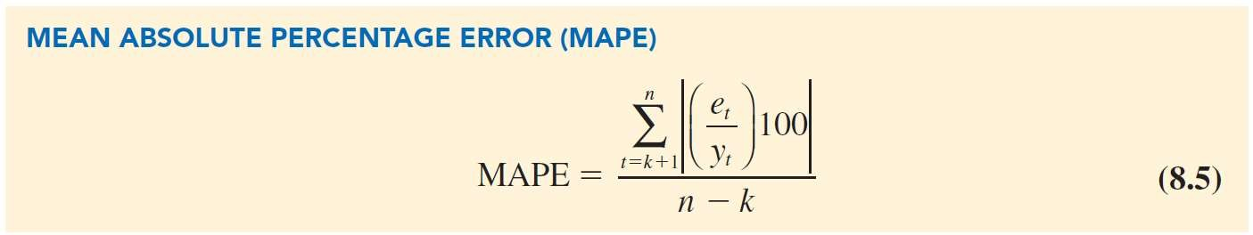

Forecast Accuracy

* How to use these measures of error?
  + Test with 2 models – Naïve vs. Averaging all past values
* **The error measures are lower for Averaging Past Values:**
  + Lower = Better
  + Averaging provides more accurate forecasts for the next period than using the most recent observation.



Forecast Accuracy

**Mean Absolute Percentage Error (MAPE)**:

Average of the absolute value of percentage forecast errors.

|  |  |  |
| --- | --- | --- |
|  | **Naïve Method** | **Average of Past Values** |
| MAE | 3.73 | 2.44 |
| MSE | 16.27 | 8.10 |
| MAPE | 19.24% | 12.85% |

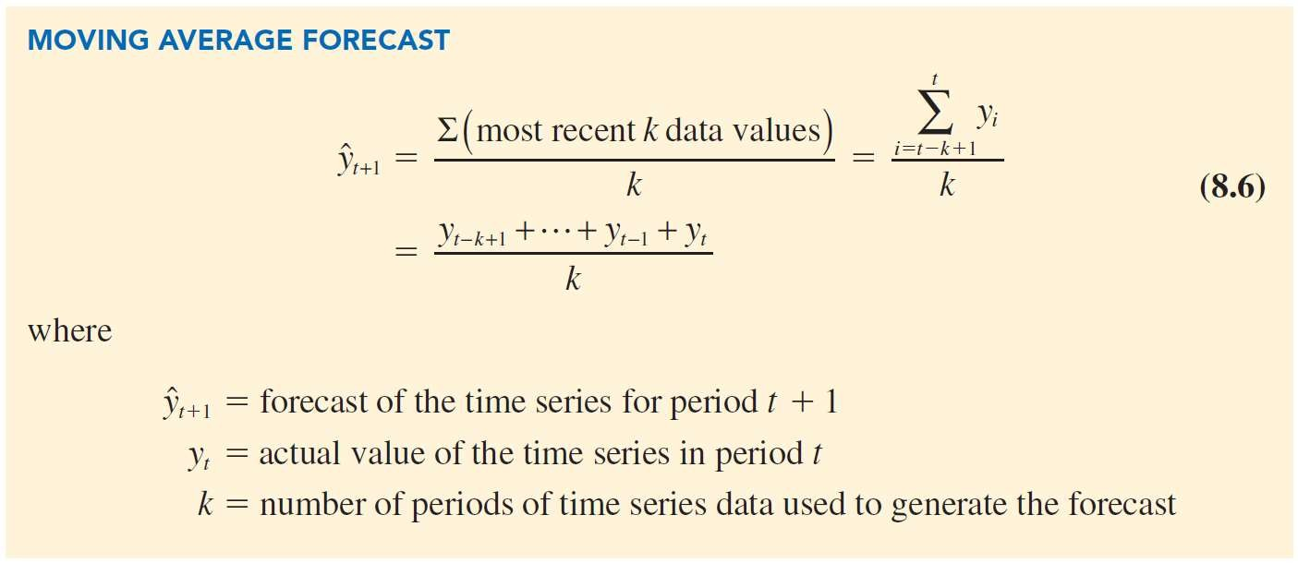

Moving Averages and Exponential Smoothing

Forecasting Methods for Horizontal Patterns



Moving Averages and Exponential Smoothing

**Moving Averages:**

* Uses the average of the most recent *k* data values in the time series as the forecast for the next period.

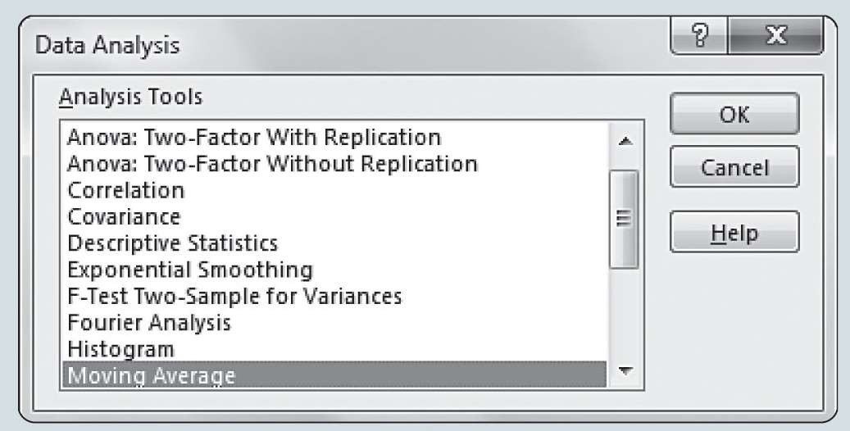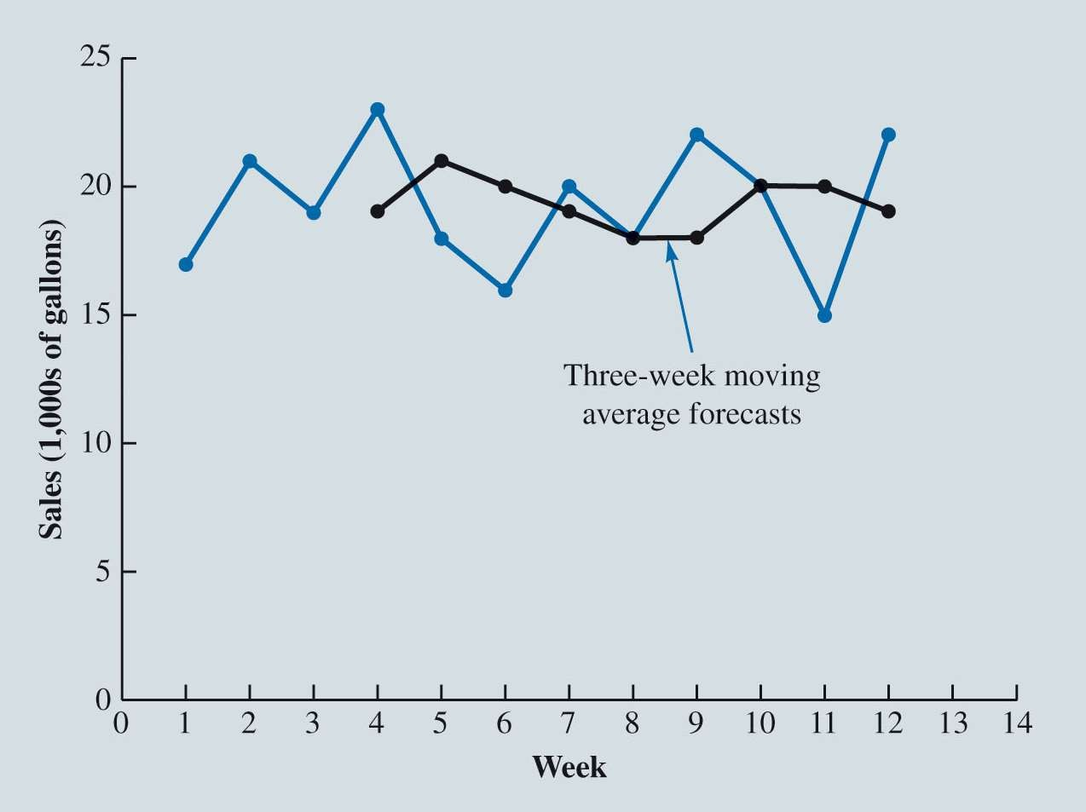

Moving Averages and Exponential Smoothing

Figure 8.7: Gasoline Sales Time Series Plot and Three-Week Moving Average Forecasts

* Predict Week 4 gasoline sales:
  + Average Week 1 – 3

3

* Predict Week 5 gasoline sales:
  + Average Week 2 – 4
* 17+21+19 = 19
* 21+19+23 = 21

3



Moving Averages and Exponential Smoothing

Figure 8.8: Data Analysis Dialog Box

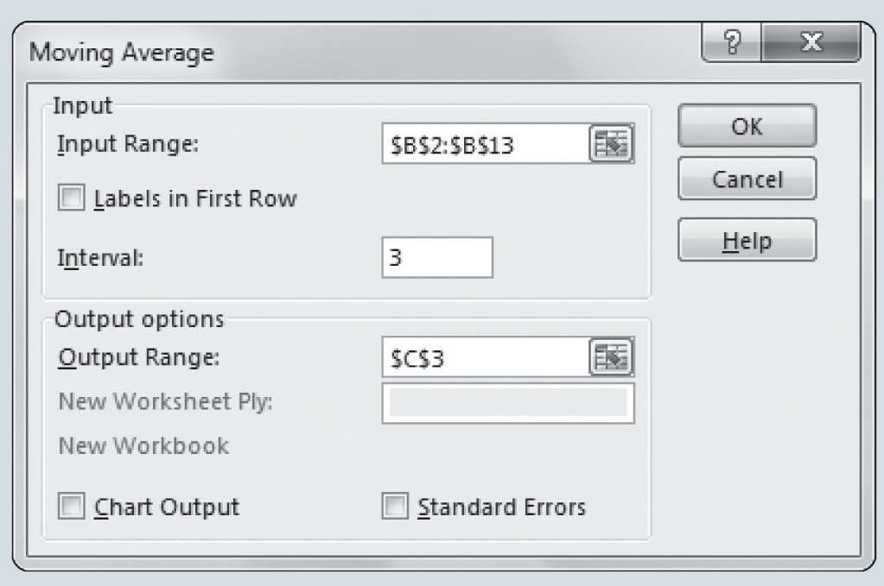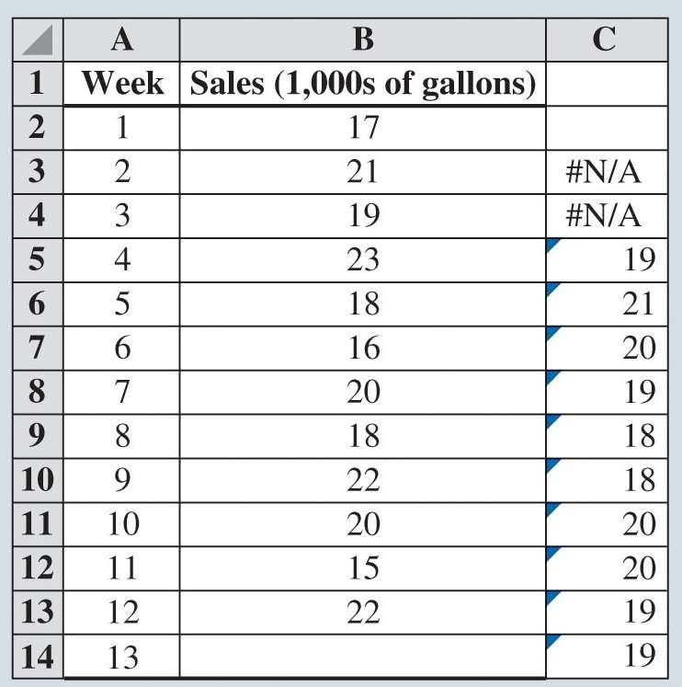

Moving Averages and Exponential Smoothing

Figure 8.9: Moving Average Dialog Box



Moving Averages and Exponential Smoothing

Figure 8.10: Excel Output for Moving Average Forecast for Gasoline Data



Moving Averages and Exponential Smoothing

Forecast Accuracy:

The values of the three measures of forecast accuracy for the three-week moving average calculations in Table 8.9.

MAE =

∑ 124 𝑒t

t=

24

𝑛 − 3 9

= = 2.67

MSE =

∑124 𝑒2

𝑛 − 3 9

t= t =

92

= 10.22

∑12

t=4

𝑒t 100

MAPE =

𝑦t

𝑛 − 3

=

129.21

9

= 14.36%



|  |  |  |
| --- | --- | --- |
|  | **K = 1** | **K = 3** |
| MAE | 3.73 | 2.67 |
| **MSE** | 16.27 | 10.22 |
| **MAPE** | 19.24 | 14.36 |



Moving Averages and Exponential Smoothing

* **Exponential Smoothing:**
  + Exponential smoothing uses a weighted average of past time series values as a forecast.

Smoothing constant (**) is the weight given to the actual value in period *t*; weight given to the forecast in period *t* is 1  **.



3.

period 1; that is, *y*ˆ = *y* .

1 1

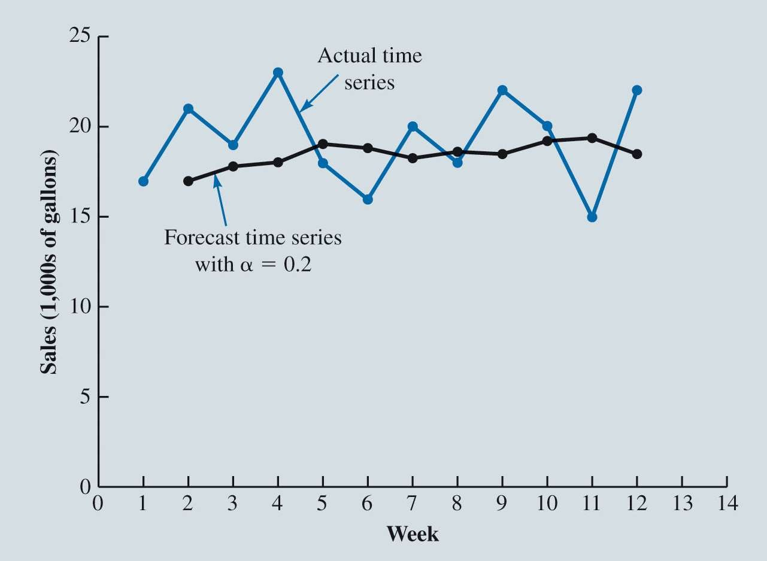

Moving Averages and Exponential Smoothing

**Illustration of Exponential Smoothing:**

**Illustration of Exponential Smoothing:**

* Consider a time series involving only three periods of data: 𝑦1, 𝑦2, and 𝑦

Let *y*ˆ1 equal the actual value of the time series in

Hence, the forecast for period 2 is:

𝑦^2 = 𝛼𝑦1 + 1 − 𝛼 𝑦^1

= 𝛼𝑦1 + 1 − 𝛼 𝑦1

= 𝑦1



Moving Averages and Exponential Smoothing

**Illustration of Exponential Smoothing:**

Actual and Forecast Gasoline Time Series with Smoothing Constant 𝛼 = 0.2

𝑦^2 = 𝛼𝑦1 + 1 − 𝛼 𝑦^1

𝑦^2 = .2(𝑦1) + .8 𝑦^1

𝑦^2 = .2 17 + .8 17

𝑦^2 = 17

𝑦^3 = 𝛼𝑦2 + 1 − 𝛼 𝑦^2

𝑦^3 = .2(𝑦2) + .8 𝑦^2

𝑦^3 = .2 21 + .8 17

𝑦^3 = 17.8

𝑦^4 = 𝛼𝑦3 + 1 − 𝛼 𝑦^3

𝑦^4 = .2(𝑦3) + .8 𝑦^3

𝑦^4 = .2 19 + .8 17.8

𝑦^4 = 18.05

𝑦^13 = 𝛼𝑦12 + 1 − 𝛼 𝑦^12

𝑦^13 = .2(𝑦12) + .8 𝑦^12

𝑦^2 = .2 22 + .8 18.48

𝑦^2 = 19.18

Box

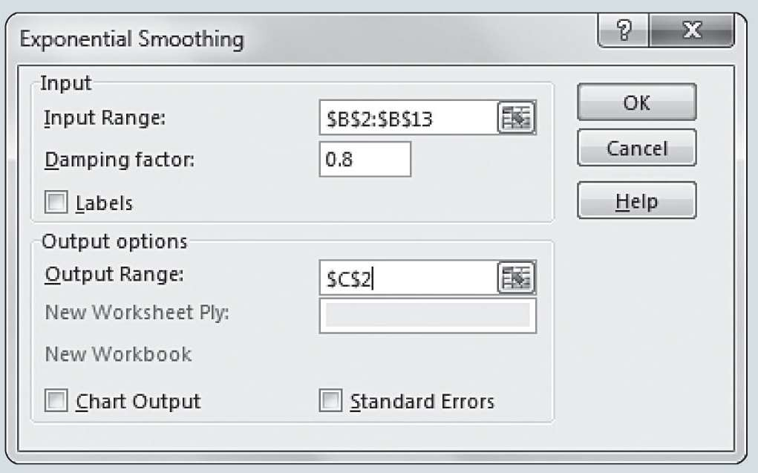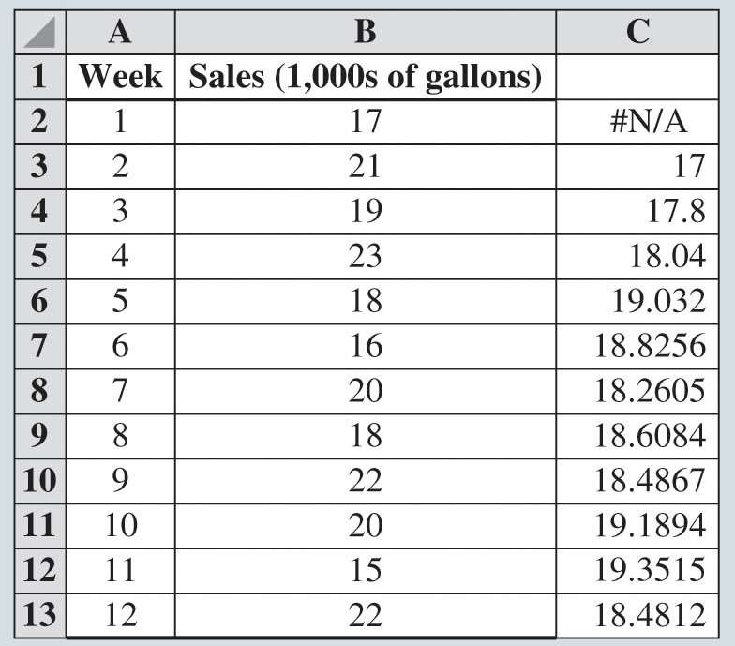

Moving Averages and Exponential Smoothing

Figure 8.13: Exponential Smoothing Dialog



Moving Averages and Exponential Smoothing

Figure 8.14: Excel Output for Exponential Smoothing Forecast for Gasoline Data



Moving Averages and Exponential Smoothing

**Forecast Accuracy:**

Insight into choosing a good value for ** can be obtained by rewriting the basic exponential smoothing model as:

*y*ˆ = *y* + (1  ** )*y*ˆ

*t* +1 *t*

*t*

= *y* + *y*ˆ  * y*ˆ

= *y*ˆ*t* + ** (*yt*  *y*ˆ*t* )

*t t t*

= *y*ˆ + *e*

*t t*

If the time series contains substantial random variability, a small value of the smoothing constant is preferred and vice-versa.

Choose the value of ** that minimizes the MSE.